- We expect the Bank of England's Monetary Policy Committee to cut Bank Rate by 25bps at next week's meeting, with the vote likely to be in the region of 6-3 to 8-1. Although Huw Pill and Megan Greene opposed the August rate cut and remain concerned about inflation persistence, both have suggested that gradual monetary loosening is the most appropriate policy approach.
- The MPC is likely to revise up its growth forecasts for 2025 and 2026 due to lower interest rate expectations, a lower oil price, and the extra government spending announced in the Budget.
- The impact on inflation will be a key signal about the extent to which the MPC thinks the growth/inflation trade-off has improved. If the MPC continues to forecast below-target inflation, it would suggest greater confidence in its most benign scenario, raising the chances of back-to-back rate cuts.
The Bank of England's Monetary Policy Committee is in the early stages of its rate cutting cycle, which started with a 25bps cut in August followed by a hold in September. We regard another 25bps cut at November's meeting as almost a certainty. Our primary question for next week's meeting is whether there will be any indication that the majority of MPC members are willing to depart from the 'cut-hold' tempo and back a faster pace of rate cuts through the winter.
The three scenarios set out by the MPC in the minutes of recent meetings are the best way of assessing the committee's thinking (Chart 1). Scenario 1 is the most benign, as underlying inflationary pressures dissipate quickly without unemployment rising significantly or the MPC needing to keep policy very restrictive. Scenario 3 implies the tightest policy stance, where the structural shifts in wage- and price-setting behaviour in recent years prove more persistent, so a period of higher unemployment is required to keep inflation at the 2% target on a sustained basis. Scenario 2 is effectively a middle ground between the two extremes, implying a gradual pace of rate cuts.
Chart 1: Most MPC members appear to favour their mid-range inflation scenario
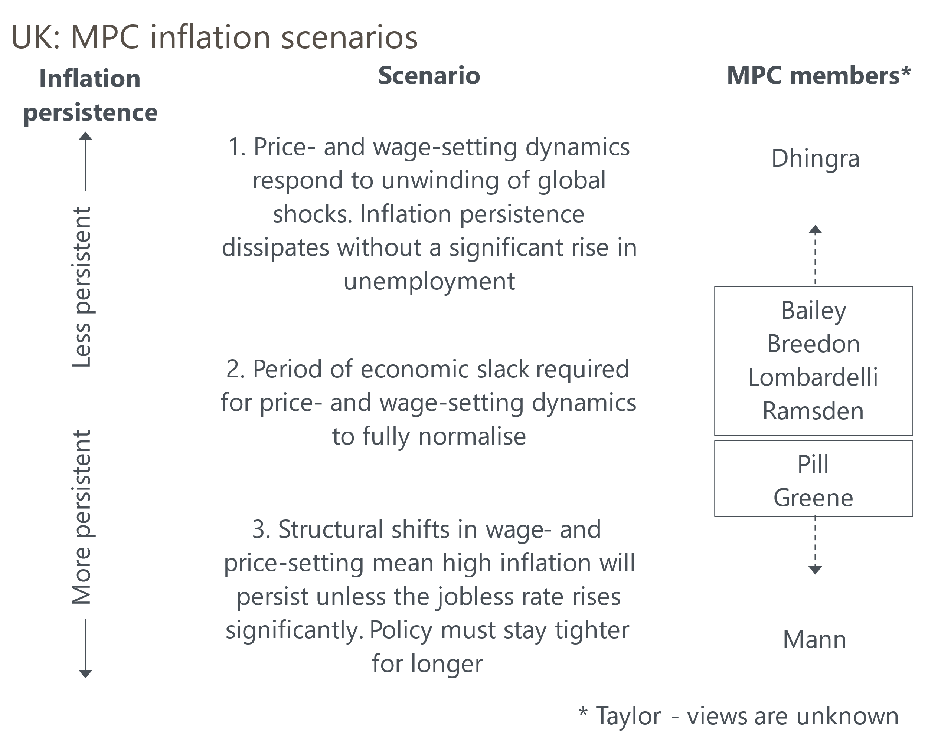
Source: Oxford Economics

Though there has been a concerted effort to refer to these scenarios in discussions about the monetary policy outlook, only a minority of MPC members have been clear about which one they consider to be their baseline (Table 1 shows our analysis of recent comments by MPC members). In Chart 1, we’ve assigned the other members based on their past votes and comments.
Table 1: Key comments by MPC members since the September meeting
Speaker and link | Date | Key takeaway
Mann | 24-Oct | Though welcoming recent downside surprises for inflation, Mann said that services inflation "still has a long way to go" and she expressed concern that goods prices have been higher than she expected of late.
Bailey | 23-Oct | Speaking in Washington, the Governor said that "disinflation has actually taken place faster than we expected it to". But he also said that "we've got to see services prices inflation come further down". We think Bailey's baseline is scenario 2 but that he views Scenario 1 as more likely than Scenario 3.
Greene | 21-Oct | In an op-ed in the Financial Times, Greene debated the consumer outlook. She concluded that the uncertainties were so great that a "cautious, gradual approach to monetary easing is appropriate."
Pill | 04-Oct | The BoE's Chief Economist said his "modal outlook is probably closest to the second case the MPC has described" but was also concerned that Scenario 3 remains a live risk.
Bailey | 03-Oct | Bailey said that if the news on inflation continues to be good, there's a good chance of the Bank becoming "a bit more activist" in its approach to cutting rates.
Greene | 25-Sep | Greene said she places the greatest probability on scenario 2 but thinks there's a higher risk of scenario 3 playing out than scenario 1.
Mann | 20-Sep | Mann, consistently the MPC's most hawkish member, said she put most weight on Scenario 3, so policy needed to "remain restrictive for longer" to "purge" systematically embedded inflation.
Source: Oxford Economics
The four internal members – Governor Andrew Bailey and Deputy Governors Sarah Breedon, Clare Lombardelli, and Dave Ramsden – continue to hold the balance of power. We think they place the greatest weight on Scenario 2, which implies a gradual loosening of policy, but that they are open to switching to Scenario 1, and the faster pace of cuts that would imply.

Recent data offers some support for the most benign scenario
Hopes that Scenario 1 might be starting to play out centre on recent inflation data. The August Monetary Policy Report included a forecast by BoE staff that showed services inflation edging down in Q3. In the event, all three monthly readings came in well below that forecast.
We think that fading base effects will slow the downward momentum and keep services inflation around 5% in the latter part of 2024. We are also cautious about reading too much into recent outturns and the relationship with the BoE's forecast. The three recent undershoots followed three similarly large overshoots of the BoE's May forecasts (Chart 2). The MPC pressed ahead with a rate cut in August despite services inflation surprising on the upside, which suggests the more dovish members of the committee were taking a more forward-looking approach and putting less store on recent data.
Chart 2: Recent BoE staff projections have yielded large forecast errors in both directions
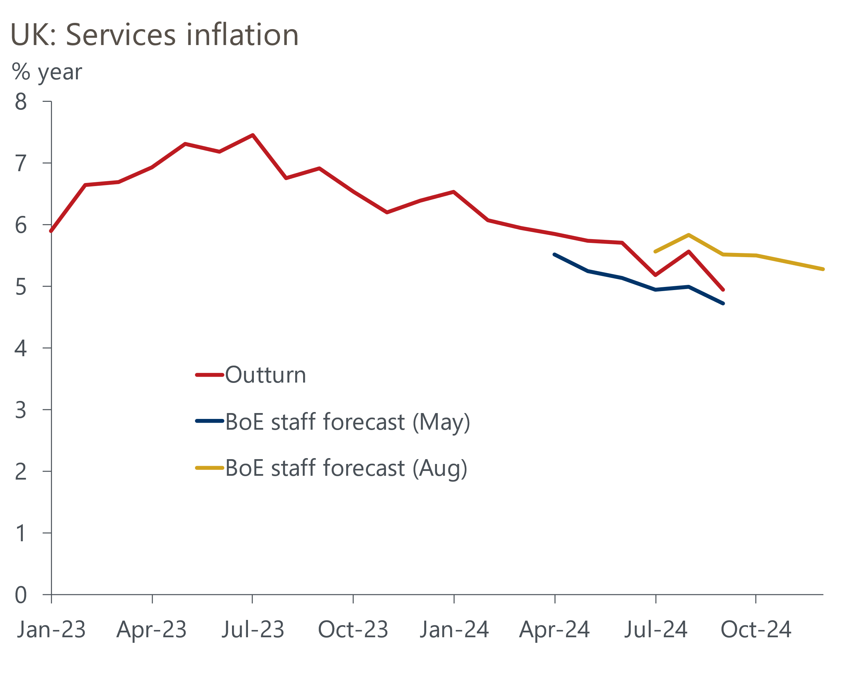
Sources: Haver Analytics, Bank of England Monetary Policy Reports, May & August 2024
The BoE's projections for private sector pay growth have been more accurate, which supports the argument that although pay pressures are gently easing, they are still at a level that the MPC considers to be too high to consistently meet the inflation target over the medium-term. The BoE's latest Decision Maker Panel tells a similar story and suggests firms expect this pattern to continue over the coming quarter.
On balance, the recent data implies the risks have tilted towards Scenario 1 playing out, with Scenario 3 looking slightly less likely. But the evidence is far from clear cut.

The MPC's near-term growth forecast is likely to be stronger
In the minutes of the September meeting, the MPC highlighted the importance of next week's forecast update. Its August forecast showed inflation dropping well below the 2% target after two years and falling further in the third year. This was consistent with a relatively pessimistic growth forecast that showed GDP rising by a meagre 1% in 2025 and 1.25% in 2026.
The MPC will almost certainly upgrade its growth forecast. The November forecast will be based on a market curve that shows Bank Rate around 40bps lower in mid-2025 (Chart 3). Meanwhile, the sterling oil price is 14% lower than it was ahead of the August forecast round. All else equal, these factors could add around 0.25ppts to the MPC's forecasts for GDP growth in 2025 and 2026.
Chart 3: Markets expect 40bps of extra rate cuts by the middle of next year
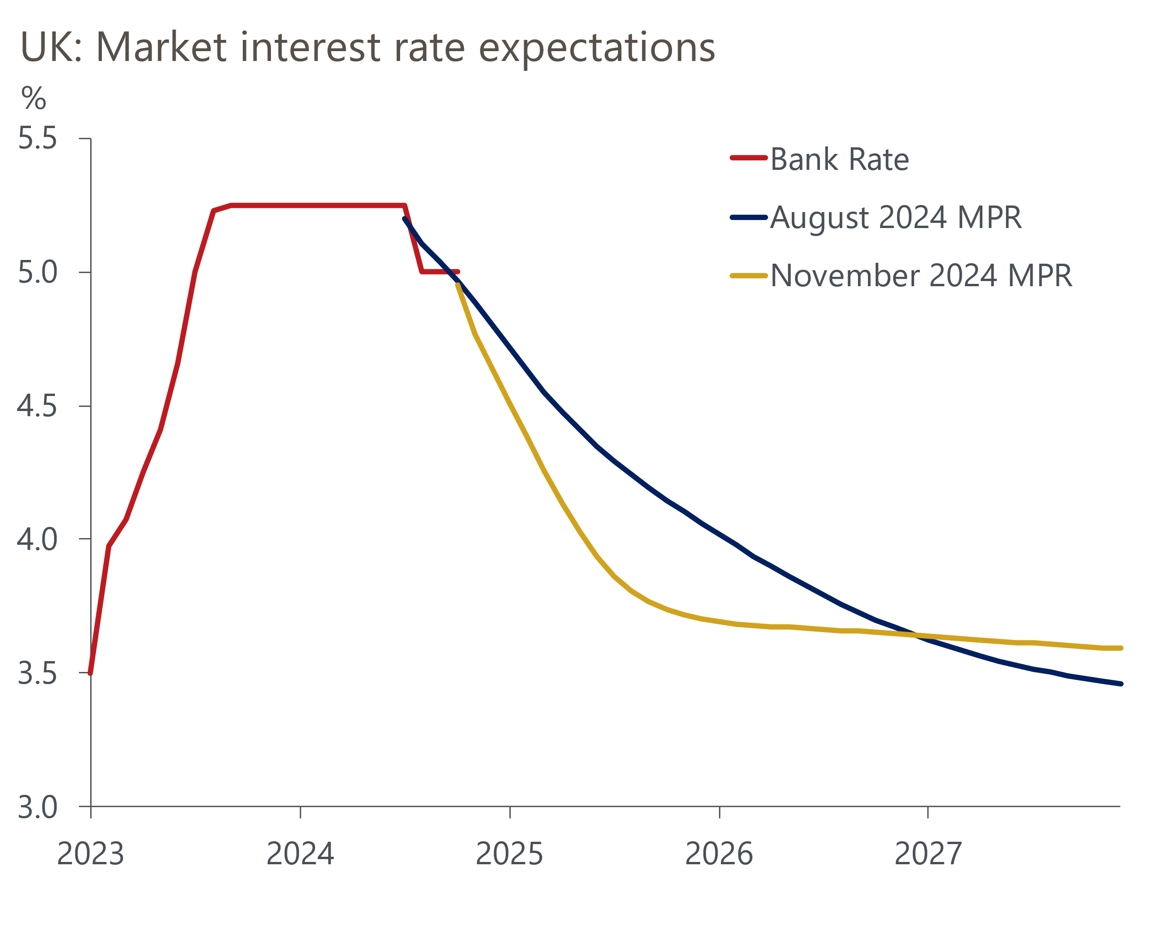
Source: Haver Analytics
It's unlikely that the BoE will be able to take on board the full implications of the Budget in the new forecasts, but it will probably include a rough estimate. The Office for Budget Responsibility concluded that the measures would boost GDP by around 0.5ppts in 2025-2026 compared with the previous plans, largely because higher current spending is assumed to provide a substantial boost to government consumption. We think the OBR is too optimistic given the way that public sector output is measured and that higher public sector wages account for some of the increase in spending. But if the BoE takes the OBR's estimates at face value, then this implies a further boost to the growth forecast.
Given the near-term growth forecast is likely to be stronger, implying greater capacity constraints, changes to the MPC's inflation forecast will highlight the extent to which the balance of risks has shifted towards its most benign scenario. Maintaining a forecast that shows inflation falling well below target, despite lower interest rates and stronger growth, would imply that the growth/inflation trade-off has improved and would increase the chances of back-to-back rate cuts at some point over the next six months.

November cut is a done deal, but December is a coin toss
As of October 31, market pricing implied an 84% chance of a 25bps cut at the November meeting. We agree that a cut is almost certain. The vote is likely to be in the region of 6-3 to 8-1, with the votes of Huw Pill and Megan Greene the most unpredictable. Both voted against cutting rates in August and have since suggested that Scenario 3 is more likely than Scenario 1. But equally, both have said that a gradual approach to rate cuts is their preferred option, so they may be willing to back the cut-hold pattern that's been established in recent months.
Markets have dramatically pared back their expectations for another cut in December in response to the Budget. At present, we lean towards the cut-hold tempo continuing. But we will be watching next week's Monetary Policy Report and press conference closely for clues about how the MPC believes that the inflation/growth trade-off has changed and the degree to which the majority believes that the risks have tilted towards Scenario 1.

